PIMMS Guide
Install
This is the page on which you are importing all the data that will be processed through PIMMS.
On install, PIMMS creates a user-friendly folder containing all data that will be needed for running in the Documents folder. Simply go to the Documents folder and look for “PIMMS”.
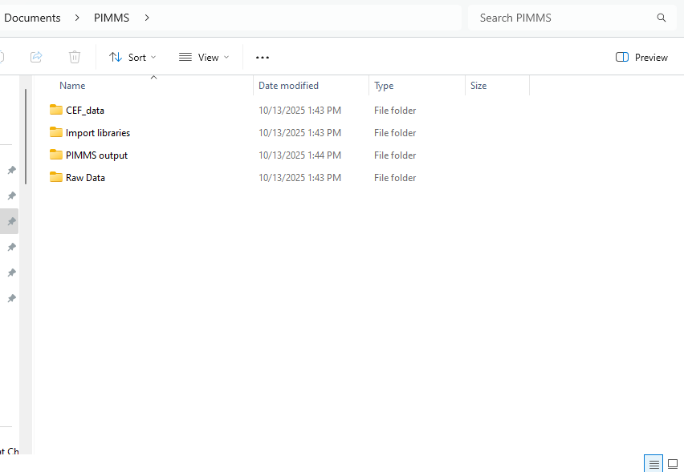
Here, all libraries needed to score data are included. These libraries are included as default options although you are more than able to modify any library or use your own and simply specify their format.
Tab: Files Path
The “Raw Data Input” is where you import your feature list. Your feature list must be a .csv file. This feature list must contain the following columns – ID, m/z, CCS, DT, RT, and then the intensities of each sample. Two sample groups should be present – an experimental and a control population.
“Standards for Removal”. This corresponds to standards you wish to exclude from your final report; typically, mass labeled PFAS such as those contained in MPFAC-HIF-ES which PIMMS will remove by default. If you wish to remove other peaks, simply go to Documents>PIMMS>Import libraries>Mass Labelled… and edit or upload your own version. It simply needs a m/z column and a CCS column and any feature matching to that peak will be removed.
“Level 2 Library”. This corresponds to previously ran standards for which a validated CCS and m/z exist. RT can also be used in scoring as well. By default, PIMMS is packaged with the Baker Lab’s reversed phase liquid chromatography library consisting of 119 features representing 104 unique PFAS for which an analytical standard has been run. If you would like to add to the library then read in any library you would like, or add entries to the library.
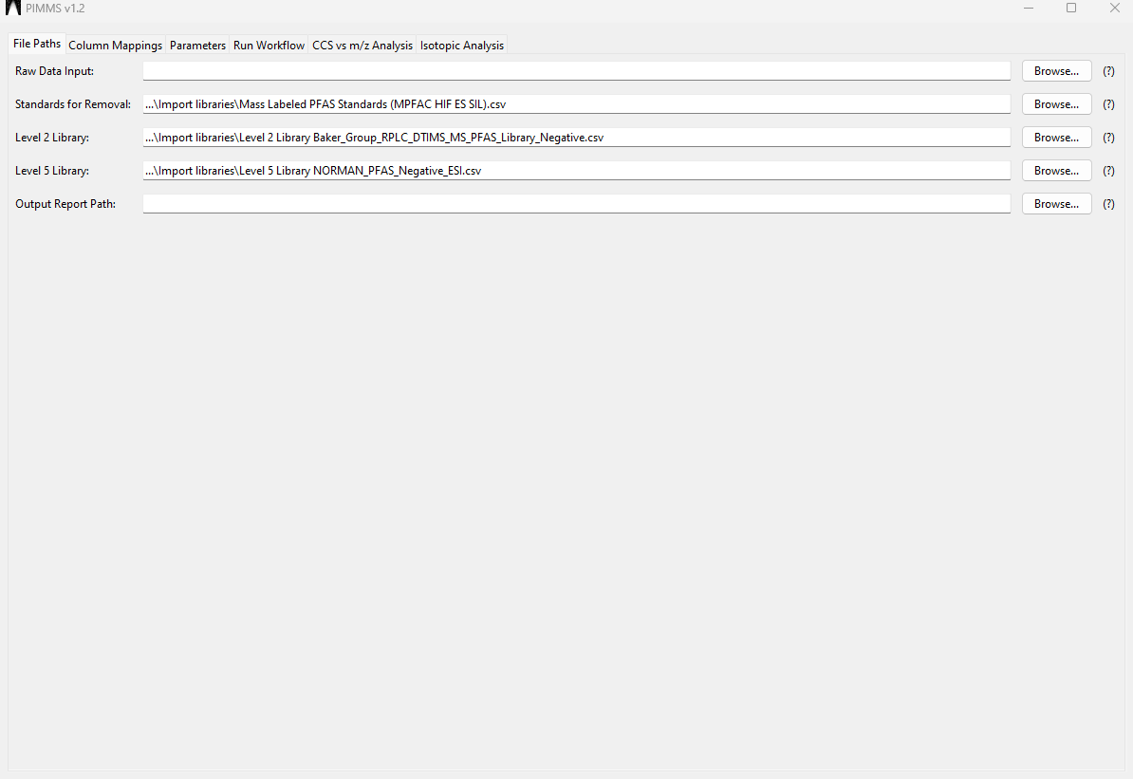
“Level 5 Library”. This corresponds to PFAS which exist in external compound libraries that possess a validated structure, however, no standard is available for further structural confirmation. By default within PIMMS, a library of 573 features are scored against taken from the NORMAN Suspect List Exchange. Note, NORMAN updates this database multiple times a year with the most recently discovered suspects. Prior to integration features are filtered by their preferred ionization mode, selecting only “RPLC_ESI-“ and “ESI-“.

“Output Report Path”. This is the location your PIMMS report will be outputted. Hit browse and select any location and name you would like it to have.
Column Mappings
Here, we are mapping PIMMS to whatever your sample set is. This eliminates several sticking points when working with external data (i.e. m/z is named “mass to charge” or worse mass:charge).
The “Metadata Column Letters (Raw Data)” section enables you to import data with any column ordering desired. By default, PIMMS loads with ID in A, RT in B, DT in C, CCS in D, and m/z in E. However, this is entirely flexible, and if you have m/z in AZ, then just specify that.
Then; everyone’s data is different. To overcome this, PIMMS allows you to specify the size of your data set. Simply specify the first column that your control population begins in, and then the last column. Then do the same for the experimental population.
“Level 2 Library Column Letters” corresponds to the mapping of the CCS library. PIMMS by default is configured to work with the Baker Lab’s CCS library, however, if another library is used, simply modify the column mappings to align with your library. Exact column names are not important; PIMMS is configured to work with any column name so long as the correct column is specified.
“Level 5 Library Column Letters” corresponds to the mapping of the external library. PIMMS by default is configured to work with the NORMAN suspect library, however, if another library is used, simply modify the column mappings to align with your library. Again, exact column names are not important; PIMMS is configured to work with any column name so long as the correct column is specified.
“Standards Library Column Letters” corresponds to the mapping of the standards you wish to remove. PIMMS by default is configured to work with the file packaged in Documents>PIMMS>Import Libraries>Mass Labeled…, however, if another library is used, simply modify the column mappings to align with your library. Again, exact column names are not important; PIMMS is configured to work with any column name so long as the correct column is specified.
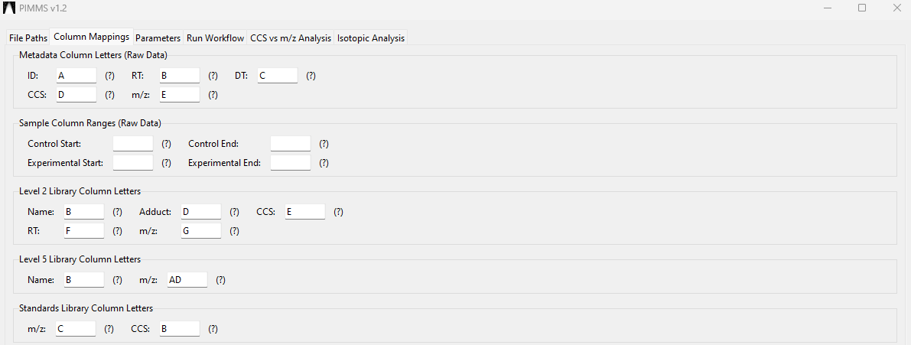
File Tab: Parameters
Here, we are specifying all the parameters necessary to score and filter data.
Tolerances and Filters
Mass Error (ppm) – the mass error that is considered a “match”. For a run in which mass errors for known suspects are consistently within -10 - +10 ppm, I use an error of 15 ppm as peak alignment algorithms can shift the mass by a few ppm.
CCS Tolerance (%) – the error in CCS that is considered a “match” typically set to a max of 2%. Due to alignment algorithms, small errors can be propagated, so a <1% error in Browser is best targeted with a max 2% error.
RT Tolerance (min) – the acceptable bounds that a feature can have to be considered a match in scoring.
Minimum Intensity – the minimum intensity a sample’s feature must have to be recorded. If the limit is 500 and there are 5 samples, Sample A: 50, Sample B: 50, Sample C: 5000, Sample D, 100, Sample E: 5000 the resulting matrix would be Sample A: 0, Sample B: 0, Sample C: 5000, Sample D, 0, Sample E: 5000.
Minimum RT, Maximum RT – sets the bounds for which a sample can be considered. By default PIMMS is set to 2 – 16 minutes as this corresponds to the “reliable” data range within the Baker Lab’s RPLC method. However, you are welcome to set to any range desired.
Detection Frequency (%) – the minimum number of times a feature must be detected (after intensity filtering) to be counted. I.e. a detection frequency of 100% for a sample set of 5 samples, the feature must be detected in 5/5 samples above the intensity threshold.
Minimum m/z – maximum m/z – sets the mass range for analysis.
Mass Defect Filter – The bounds for which features are filtered by defect. A max upper bound of 0.09 and lower bound of -0.194 are set as this is found to align with the 5th – 95th percentile bounds for NORMAN’s PFAS chemicals – including brominated, chlorinated, and iodine-containing features.
Blank Subtraction Method –
Method 2 – normal mean + standard deviations. Whatever the control range is, the mean and standard deviations will be calculated. Then depending on the value provided in the next box, a multiple of the standard deviations will be added. So Method 2 with 3 standard deviations would be $x-\left(μ+3σ\right)$
Method 1 – Whatever the most abundant feature is in the control population is subtracted from the experimental population. So a control population of 10, 0, 5, 1000, would result in a value of 1000 which is subtracted from all experimental samples.
Regression Analysis – Here, the Level 2 library is used to create a 10th – 90th percentile logarithmic equation to determine where a typical PFAS sits in the CCS v m/z or RT v m/z relationship. This serves to greatly reduce the feature list, however, can eliminate PFAS in the feature list with unusually low degrees of fluorination or odd chromatography relative to their size.
Scoring Options
Include Retention Time in Scoring – This allows you to include retention time scoring in your analysis. This only applies to matching to the level 2 library. Typically this is left unchecked for larger more complex matrices due to the potential for retention time shifting with matrix effects.
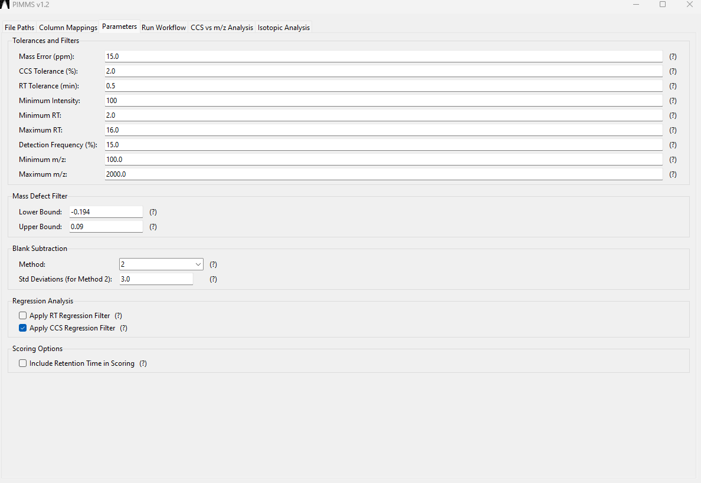
Run Workflow
Hit Run PIMMS Workflow and it will parse your data and produce a PIMMS report to the output location specified on the File Paths location. Typically a 100,000 feature report (10,000 features in 10 samples) will take around 1 minute to complete on a powerful computer. Running on a less powerful computer is possible, however, run times will increase.
CCS vs m/z Analysis
In my opinion, this is the most useful part of PIMMS – there’s tons of features, but which ones are actually on a homologous series trend line with other features. To operate it, simply upload a PIMMS file to the “Load Experimental File” and specify the column ordering; by default it is set to the PIMMS normal output.
Then, comparisons can be made to an external library to determine if a feature may align by a given repeat unit to another feature in a library. I.e. you see the 17-C PFCA, but the library only has 4-16 C PFCAs, here you would be able to see that your 17-C PFCA may lie in trend with the rest of the library if it is the same conformer.
Analysis Parameters:
Repeat Unit: set by default to CF2, but can be changed to any of 5 repeat units. If more are desired, request on my GitHub.
PPM Error: max error range for a match in a repeat unit analysis. Again, for a 5 ppm run, set slightly wider to account for potential alignment algorithm shifting in feature processing algorithms.
Min. Series Points: The number of points that must be within a series for the series to be retained. Note a “point” is only considered valid if it possess a point at least 10 Da away. I.e. a repeat unit of 50 and minimum series of 3 would meet the criteria for 100, 150, 200, but would fail if the points were 100, 100, 150, even though these features are in series with each other. However, 100, 150, 150, 200 would be reported as there are 3 points which have at least 10 Da separation. The minimum number of points is limited to 3 for obvious reasons.
Min. Library Points: Gives you the option to only select trends that report a certain number of features originating from the library. Can be set at any value from 0 on up. A library point is represented as a red x In the 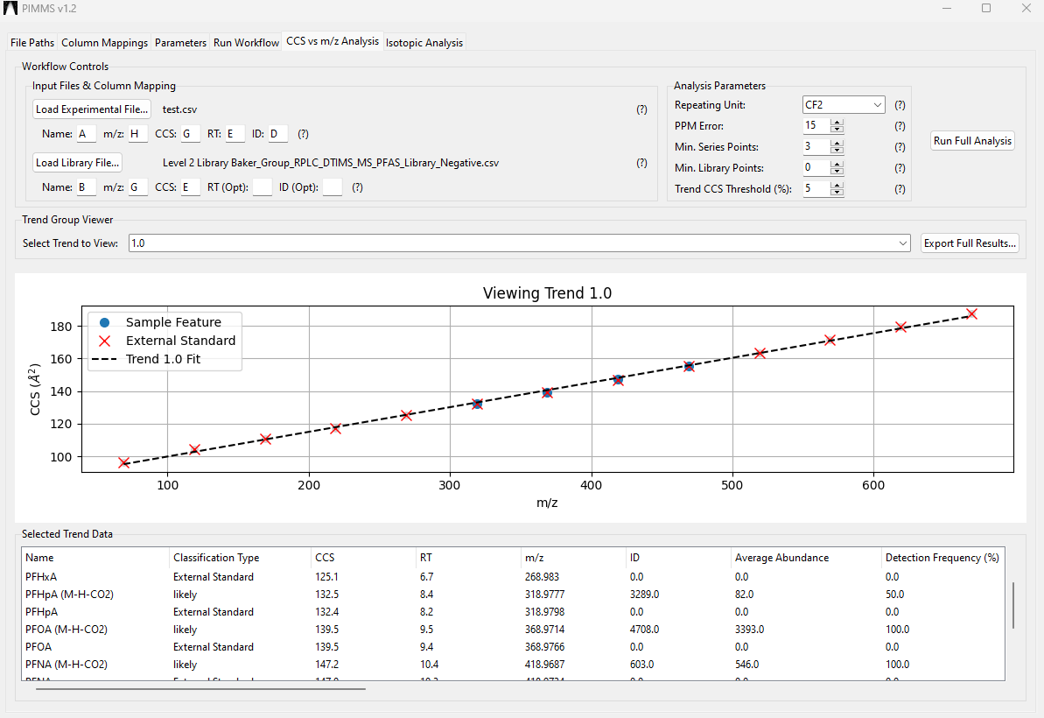

Network, N. et al. (2025) S0: Susdat: Merged norman suspect list: Susdat, Zenodo. Available at: https://doi.org/10.5281/zenodo.15583645 (Accessed: 13 October 2025).

